Speed and Velocity Problems
s
Displacement
v
Velocity
t
Time
Distance
Speed
Time
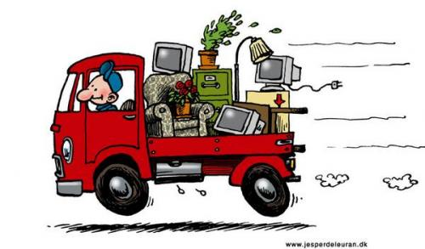

- A car travels 400m in 20s. Calculate the average speed of the car in m/s.
- A cyclist travels 30km in 12 minutes. Calculate the cyclist’s average speed.
- A train is travelling at 10m/s. How far does the train travel in 5 seconds?
- A car is travelling at 15m/s. How long does it take for the car to travel 600m?
- A bus is travelling at 12m/s. How long does it take for the bus to travel 72km?
- A trolley travels 20 metres in 1.5 seconds. What is its average speed?
- A model car travels at 2.5 m/s for 5 seconds. How far does the car travel?
- Tim drives 400 m to the shop in 20 seconds. Calculate the average speed of the car in km/h. If the speed limit in the area is 70km/h, was Tim speeding?
- On the weekend, Barry goes for a bike ride. He travels 30km in 20 minutes. Calculate Barry’s speed in km/h.
- Tim’s car is travelling at 15m/s. How long does it take him to travel 20 km?
- Barry walks to Scott’s house, a distance of 600m in 5 minutes, but Scott is not home. Barry then walks to John’s house, 300m away and it takes him 3 minutes. Calculate Barry’s average speed.
- A plane flies 420km due north in 1 hour 40 minutes. Find the average velocity of the plane in km/h.
- A train travels 510m due south for a time of 17s. Calculate the average velocity of the train in m/s.
- A boat sails 1.2km due east for a time of 5 minutes. Find the average velocity of the boat in m/s.
- An aeroplane flies due north with an average velocity of 85m/s for 20 s. Calculate the displacement of the aeroplane.
- A lorry travels along a straight road with a constant velocity of30m/s. After a time of 15 s, how far has the lorry travelled?
- Australia IV sails in a straight line from one buoy to the next. If the average velocity is 4.8km/h and the time taken is 45 minutes, find the displacement between the two buoys.
- Beth rides her horse 3km east and then 4km north. The trip takes her 30 minutes.
  - What is the total distance Beth travelled?
  - What is her average speed in km/h?
  - What is Beth’s displacement?
  - What is her average velocity?
- Amanda drives her car 35km north and then 75km south in a time of 2 hours.
  - What is her average speed in km/h?
  - What is her average speed in m/s?
  - What is her average velocity in km/h?
  - What is her average velocity in m/s?
- A plane flies east at 250km/h for 3 hours and then south at 200km/h for 1 hour.
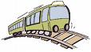
  - What is the total distance travelled?
  - What is the average speed in km/h?
  - What is the displacement?
  - What is the average velocity km/h?
- A train travels in a straight line from one station to the next at 40km/h and then returns at 60km/h. If the two stations are 2km apart, compare the average speed and average velocity for the total journey.

Challenge
Do you remember the fable of the hare and the tortoise? The giant tortoise can reach a speed of about 7.5cm/s. A hare can run as fast as 20m/s. If their race was 1km long, how long was the hare asleep if the race resulted in a tie?

